**Neuroscience & Behavior  
(Chapter 3)**

**Neuropsychology**

* Neuropsychology is a branch of psychology that aims to understand how the structure and function of the nervous system and brain are related to specific psychological processes.
* Many psychology programs use alternate names for this field, including biopsychology, physiological psychology, behavioral neuroscience and psychobiology.
* Psychologists study the brain and the nervous system because all emotions, feelings, responses influences each other.

Why do psychologist study brain and nervous system

* Because our brain is responsible for our emotions, behaviors, reactions, perceptions, cognitions, mood etc.
* Since the brain is the command center of our whole body so its nature is very important in understanding behavior and mental processes
* As Psychology is the study of human behavior and mental processes, so it makes sense

**Biological basis of behavior**

Nervous system

i-Central nervous system

ii-peripheral nervous system

**Nervous system**

Nervous system is an extensive network of specialized cells that carries information from one part to the other end/parts of the body

The nervous system is a complex network of cells that carry messages to and from the brain and spinal cord to various parts of the body.

Playing a piano, driving a car, hitting a tennis ball, all at one level, depends on the exact muscle coordination

For the muscles to produce any meaningful physical activity, the brain has to provide the messages to the right area of the body

Such messages are passed through specialized cells called neuron

**Cells of the nervous system**

Neurons :The cells that make up the nervous system, including brain, is called neuron (nerve cell)

* These specialized cells are the information-processing units of the brain responsible for receiving and transmitting information.
* Approximately 1 trillion neurons throughout the body are involved in the control of behavior.

There are also several different types of neurons responsible for different tasks in the human body.

**Sensory neurons** carry information from the sensory receptor cells throughout the body to the brain.

**Motor neurons** transmit information from the brain to the muscles of the body.

**Structure of neurons**

Most neurons have these components

* Dendrites
* A cell body
* An axon
* Axon ending (terminal buttons)

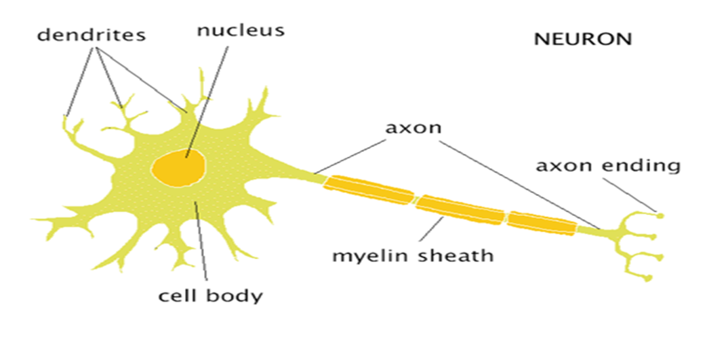

**Dendrites**

The term dendrites comes from a Greek word means “tree”.

* branch like structure that receives messages from other neurons

Receives information from other neurons and transmits it to the cell body

**Soma / the cell body**

* The main portion of the cell is called the soma or cell body.
* It contains the nucleus, which in turn contains the genetic material/information
* Soma & nucleus are responsible for maintaining the life of the cells and keep the neuron functional.
* The support structures of the cell include mitochondria, provides energy for the cell
* Much of the metabolic work occurs here.

**Axon**

* The axon is a long, slender tube, that carries the message to other cells.

*Axon is the “information sender” of the neuron,*

* The axon carries information from the cell body to the terminal buttons.
* A neuron can have any number of dendrites, but it is limited to only one axon.
* Some neurons have short axons, while others can be quite long.
* The larger the axon, the faster it transmits information

**Myelin sheath**

Some axons are covered with a fatty substance called myelin sheath that acts as an insulator (protection of impulses).

* *These myelinated axons transmit information much faster than other neurons.*
* Increase the speed of information transmition

**Axon end**

Axons end in swollen, bulb like structure called terminal buttons.

The terminal buttons are located at the end of the neuron and are responsible for sending signals from the axon of one neuron to the dendrites of neighboring neurons.

**Synapse**

* The space between the two neurons
* Between the axon ending and the dendrite of the next neuron is a very tiny gap called the synapse (or synaptic gap, or synaptic cleft),
* Information from one neuron flows to another neuron across a synapse in the form of electrical or chemical impulse.

**Nervous System**

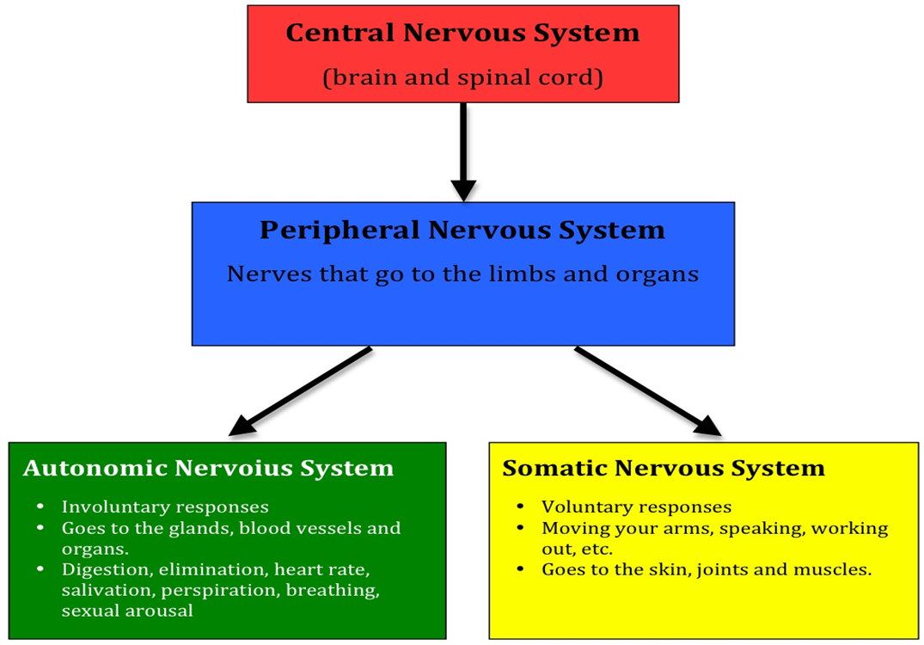

* **Central nervous system**
* brain
* spinal cord
* **Peripheral nervous system**
* Somatic
* Autonomic

**Central Nervous System**

* **Spinal Cord**

*The portion of the central nervous system that is located in the spine and plays a role in communicating information between the brain and the peripheral nervous system*

* The extension of the brain
* Bundle of neurons that leaves the brain and runs down the length of the back
* The Main means for transmitting messages between the brain and the body
* **Brain**
* The portion of the central nervous system that is located in the skull.
* It is most complex structure in the known universe.
* It is defined as a structure that contains billions of cells.
* Human brain is like one of the most powerful and sophisticated computers in the world.
* It plays important roles in sensation, movement and information processing.

*PARTS*

* The three main parts of brain are

1. Fore brain
2. Mid brain
3. Hind brain
4. **FORE BRAIN**

* Cerebrum
* Thalamus
* Hypothalamus (Part of limbic system)

1. **MID BRAIN**

* Tectum
* Tegmentum

1. **HIND BRAIN**

* Cerebellum
* Pons
* Madulla

**Fore brain**

* *The Cerebrum*
* Cerebrum is the largest and most highly developed part of the human brain. It encompasses about two-thirds of the brain mass and lies over and around most of the structures of the brain.
* It consists of two hemispheres that are connected together at the corpus callosum.
* Left hemisphere controls the right side of the body and right hemisphere controls left side of the body
* The cerebrum’s surface—the neocortex—is convoluted into hundreds of folds.
* The neocortex is where all the higher brain functions take place.

Lobes of the Cerebrum

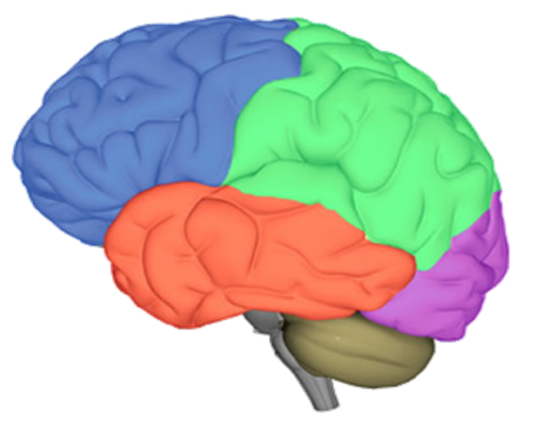

(from slides)

* Thalamus

The thalamus is called the gateway to the cerebral cortex, as nearly all sensory inputs pass through it to the higher levels of the brain. It is a relay center for incoming and outgoing signals.

* Organizes sensory information
* Motor Control
* Relays Sensory Signals to the Cerebral Cortex
* Controls Sleep and Awake States
* Hypothalamus

The hypothalamus sits under the thalamus The hypothalamus is one of the busiest parts of the brain, and is mainly concerned with **homeostasis**.  Homeostasis is the process of returning something to some “set point.”  It works like a thermostat:  When your room gets too cold, the thermostat conveys that information to the furnace and turns it on.  As your room warms up and the temperature gets beyond a certain point, it sends a signal that tells the furnace to turn off.

The hypothalamus is responsible for regulating your basic needs: hunger, thirst, response to pain, levels of pleasure, sexual satisfaction, anger and aggressive behavior, and more.  It also regulates the functioning of the **autonomic nervous system**, which in turn means it regulates things like pulse, blood pressure, breathing, and arousal in response to emotional circumstances.

**MID BRAIN**

* The **midbrain** is a portion of the central nervous system associated with vision, hearing, motor control(body and eye movement), sleep/wake, arousal (alertness), and temperature regulation.
* The midbrain is located below the cerebral cortex, and above the hindbrain placing it near the center of the brain.

It has two parts.

1. Tectum
2. Tegmentum

* The **tectum** is responsible for auditory and visual reflexes/responses.
* The **tegmentum:** floor of the mid brain
* Controls Motor Functions
* Regulates Awareness and Attention
* Regulates Some Autonomic Functions

**HIND BRAIN**

The hindbrain is the structure that connects the spinal cord to the brain.

* Cerebellum
* The cerebellum is located at the base of the brain, just above the brain stem, where the spinal cord meets the brain, The cerebellum is connected to the brainstem, and controls motor movements, balance, coordination.
* The cerebellum receives information from the sensory systems of the spinal cord, and other parts of the brain and then regulates motor movements.
* It does not initiate movement rather the cerebellum coordinates voluntary movements such as posture, balance, coordination, and speech, resulting in smooth, balanced muscular activity.
* Pons

In Latin, the word pons literally means bridge

The pons is involved in several functions of the body including:

* Arousal: waking from a sleep.
* Controlling Autonomic Functions: respiratory movements , digestive processes, dreaming, Sleep
* The Medulla Oblongata

The medulla oblongata is very smallest part of the brain, and is located directly above the spinal cord whose major function involves in involuntary reflex's

( heart rate, breathing, sneezing, coughing, blood pressure )

The Brainstem

* Brainstem connects spinal cord and brain
* It consists of Midbrain, pons, medulla oblongata
* Motor and sensory neurons travel through the brainstem between the brain and the spinal cord
* Peripheral nerves and spinal cord to the upper parts of the brain

Functions of the brain  
It picked up all information from the environment by our sense organ and transmitted by many pathways of brain to the cerebral cortex.

* Brain controls our muscular movements
* Brain stores our memory
* Brain does planning for us , plans for the future, thinks and reasons creatively.
* Brain produce our emotions**.**

**Peripheral Nervous System**

* The peripheral nervous system (PNS) is the division of the nervous system containing all the nerves that lie outside of the central nervous system (CNS).
* The primary role of the PNS is to connect the CNS to the organs, limbs and skin.
* These nerves extend from the central nervous system to the outermost areas of the body.

The peripheral nervous system is divided into two parts:

* The somatic nervous system
* The autonomic nervous system

***The somatic nervous system***

* It carries sensory information to CNS and motor information from the brain and spinal cord to muscles fibers throughout the body
* It basically controls voluntary body movement

***Autonomic Nervous System***

The autonomic system is the part of the peripheral nervous system responsible for regulating involuntary body functions, such as blood flow, heartbeat, digestion and breathing

**Endocrine System** (from slides)